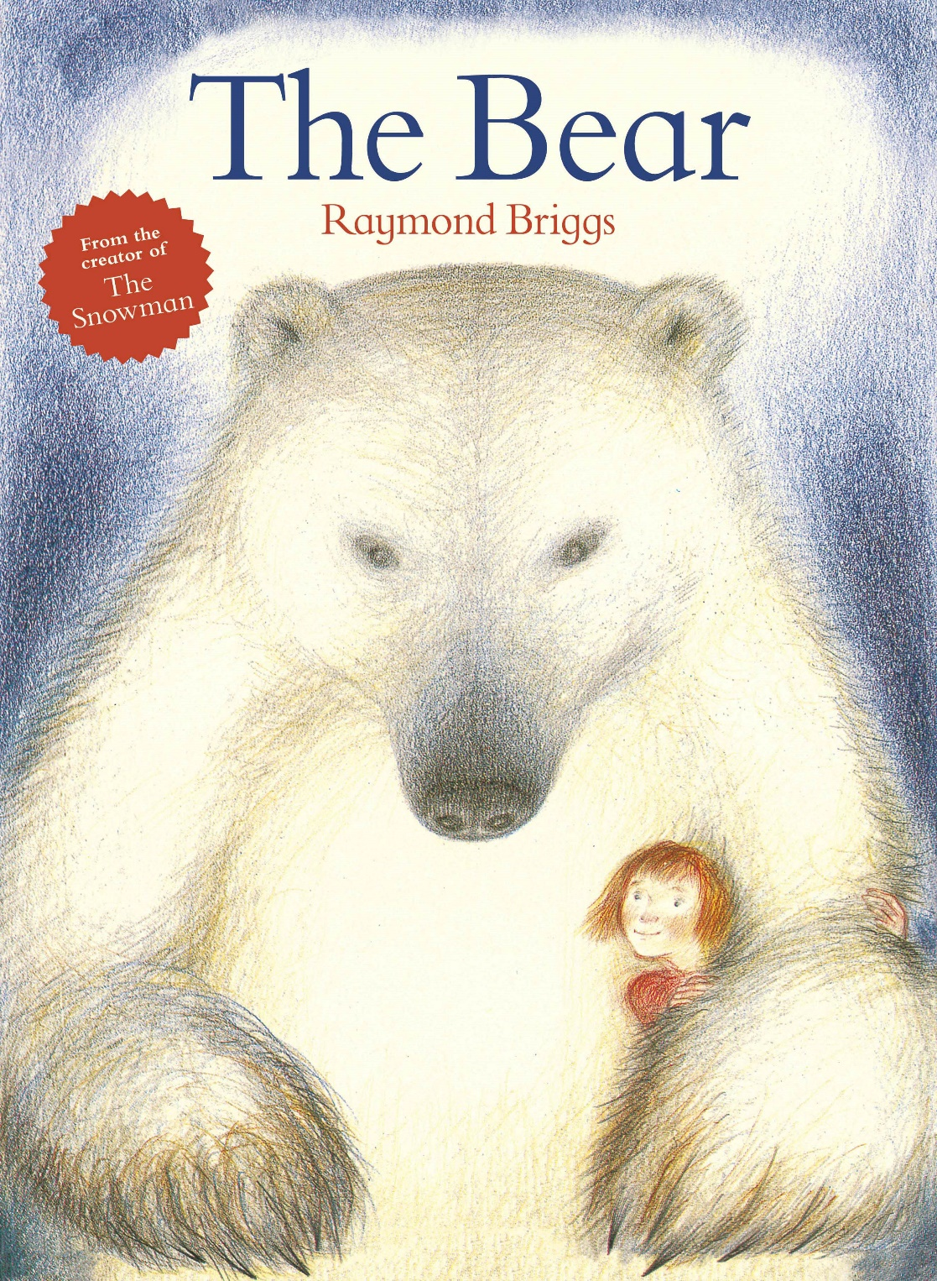

Christmas 2019 at Norden Farm

Pins and Needles Productions present
The Bear

A Visual Story
A Special Educational Needs Resource
Created by Norden Farm
1
October 2019

The Bear is a show performed at a theatre in Maidenhead called
Norden Farm Centre for the Arts.

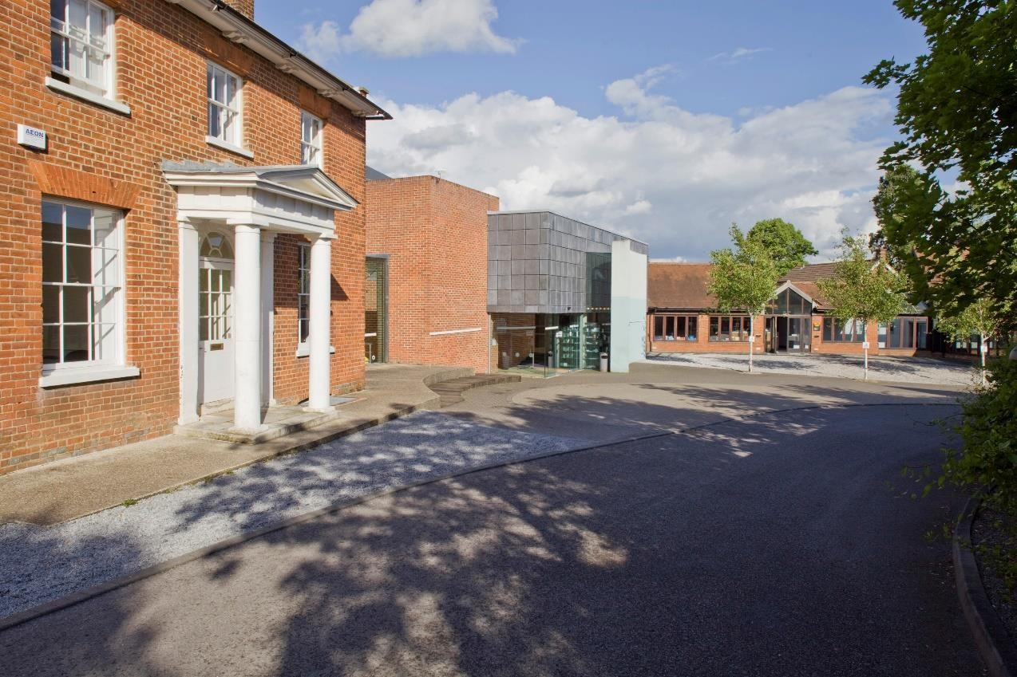

Norden Farm is located here…

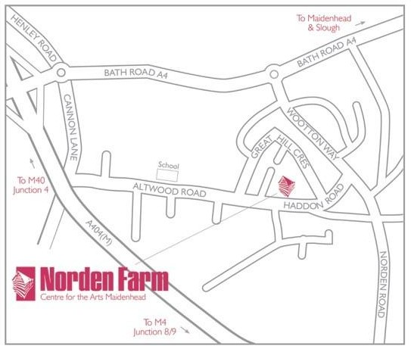

To get to Norden Farm you may walk, take a bus or the car.

You can find the theatre by looking out for the willow dancers in the front garden.

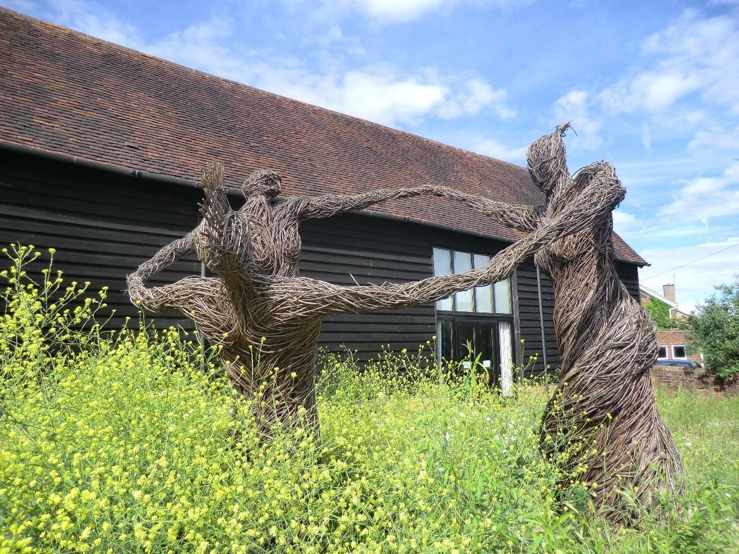

When you arrive at the theatre, you may need to collect your ticket from the
Box Office.
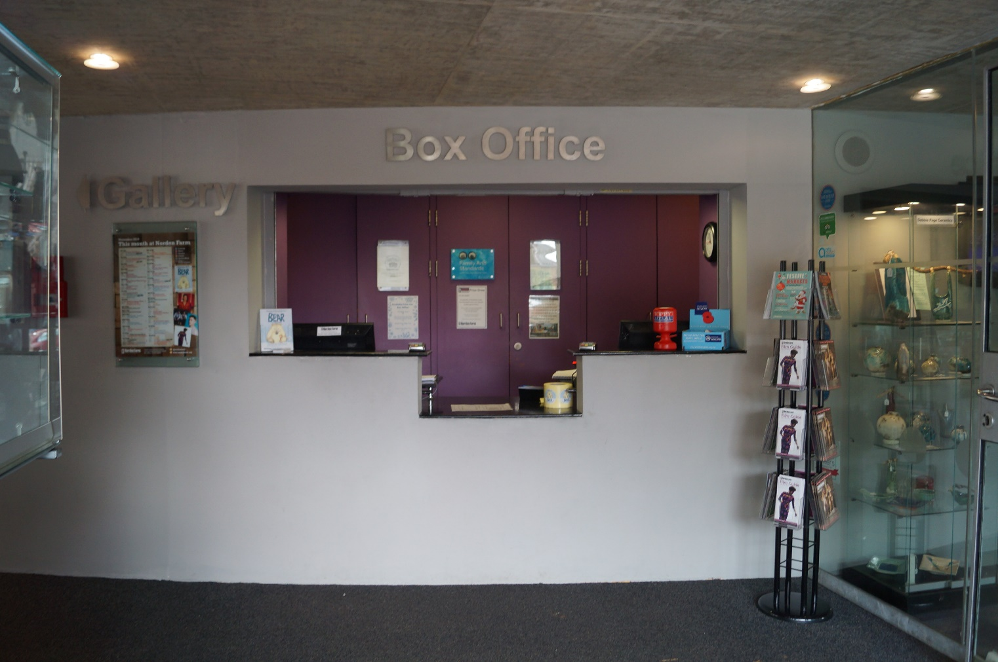

You may have to wait to go into the Theatre.
In the foyer we have lots of games to play, as well as some colouring in and activity sheets.

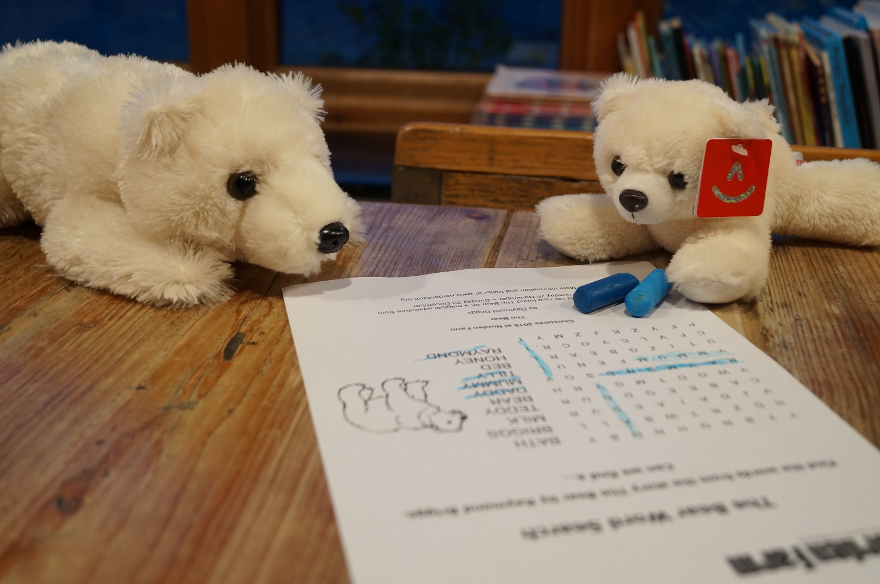

Before you go into the theatre you may want to go to the toilet. There are two wheelchair accessible toilets at Norden Farm.
You can also buy a drink and an ice cream.

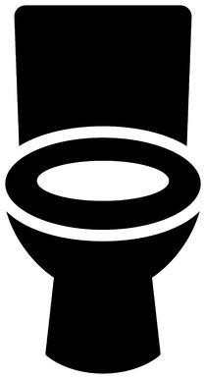

When it is time to go into the theatre you will need to show your ticket to the stewards. They will be wearing yellow t-shirts.
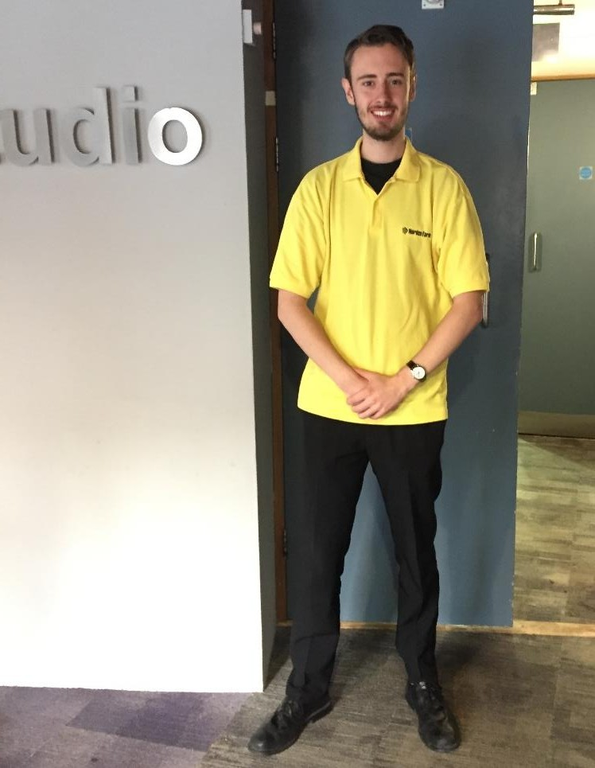

You may have to go down some stairs to access the theatre.

There is also a lift.

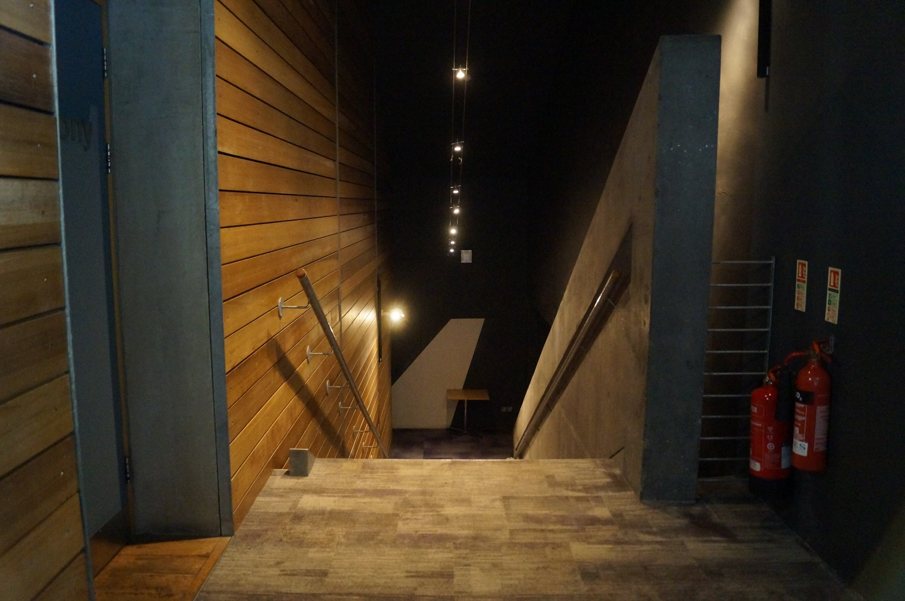

Just before the show starts, you will go into the theatre and find your seat.
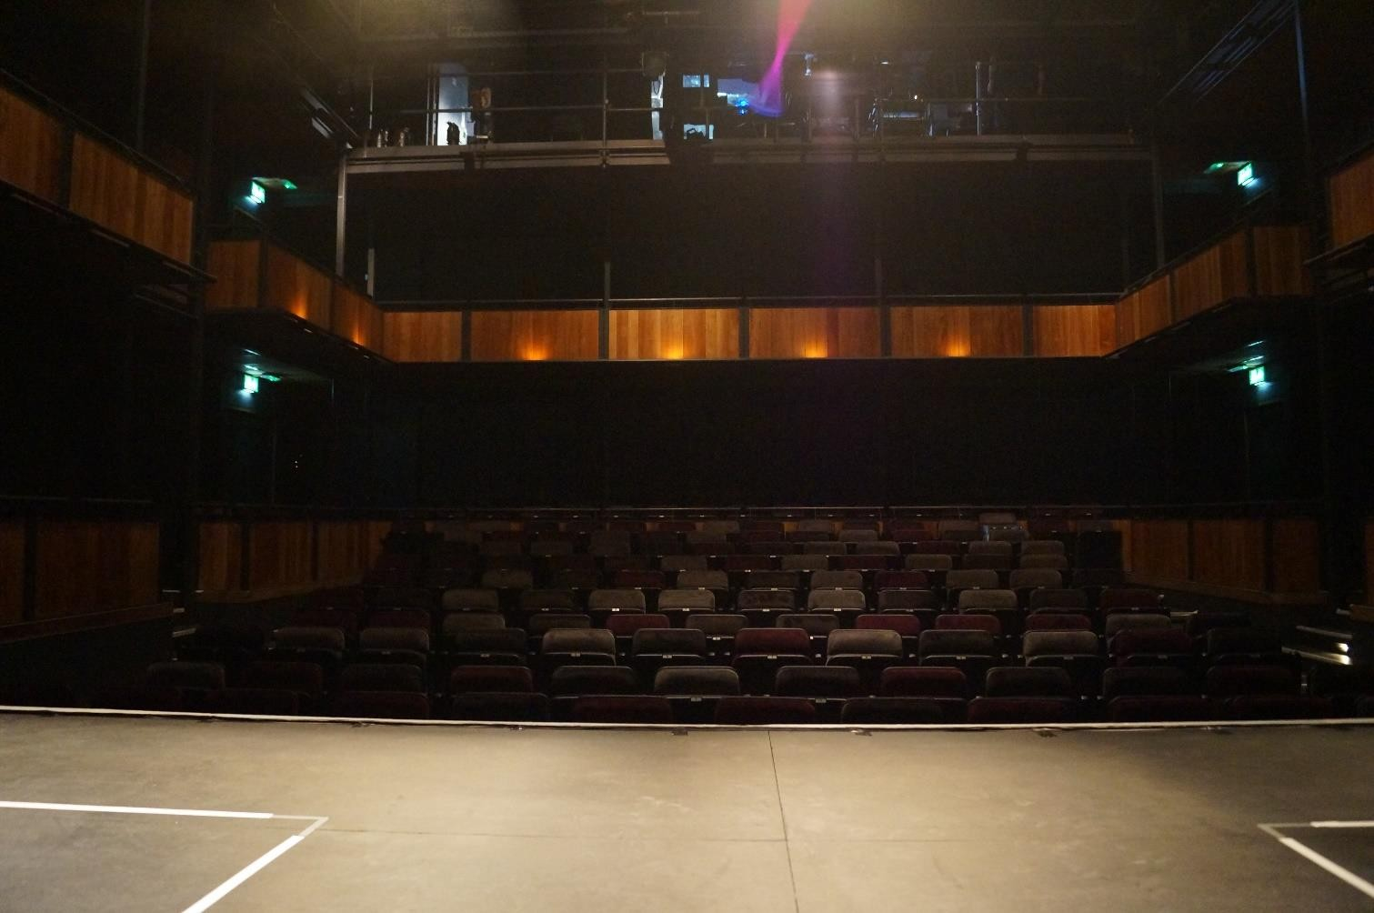
It may be dark and there may be things happening on the stage.

The show will be approximately 55 minutes long.
This is the same as watching two episodes of Octonauts.
There is no interval.

Before the show begins you must turn off your mobile phones.
You are not allowed to take photos in the theatre.

When the show starts it will get darker and quieter.
Don’t worry if you want to make noises, that is OK.
You will hear some music. Some people will clap at the end of songs and at the end of the show. If you want to clap too this is OK.
There will be bright lights and the Bear will make loud noises.

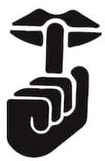

When the show ends it will be time to go home. Remember to take everything with you when you leave the theatre.

When you exit the theatre, you will leave through the doors you came in through. Then up the stairs and back to the foyer. There is also a lift.

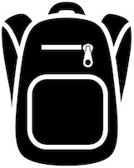
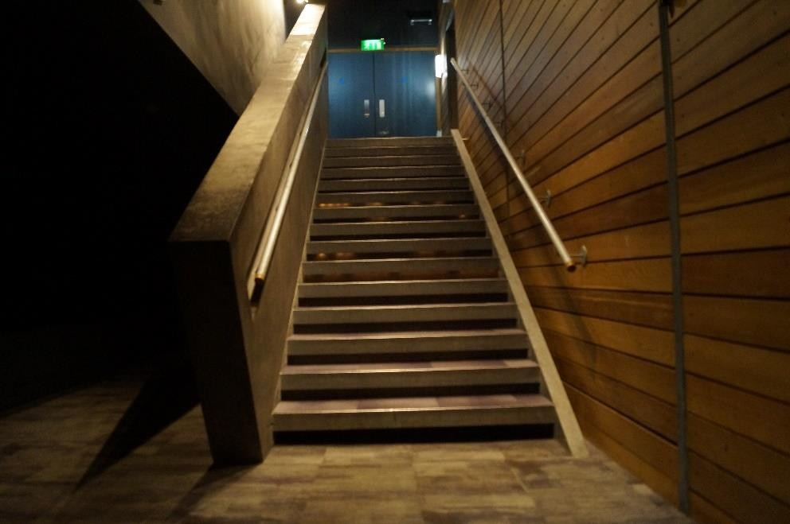

On your way out there will be a chance to buy some gifts from the show.

You may want to buy a book to read at home.
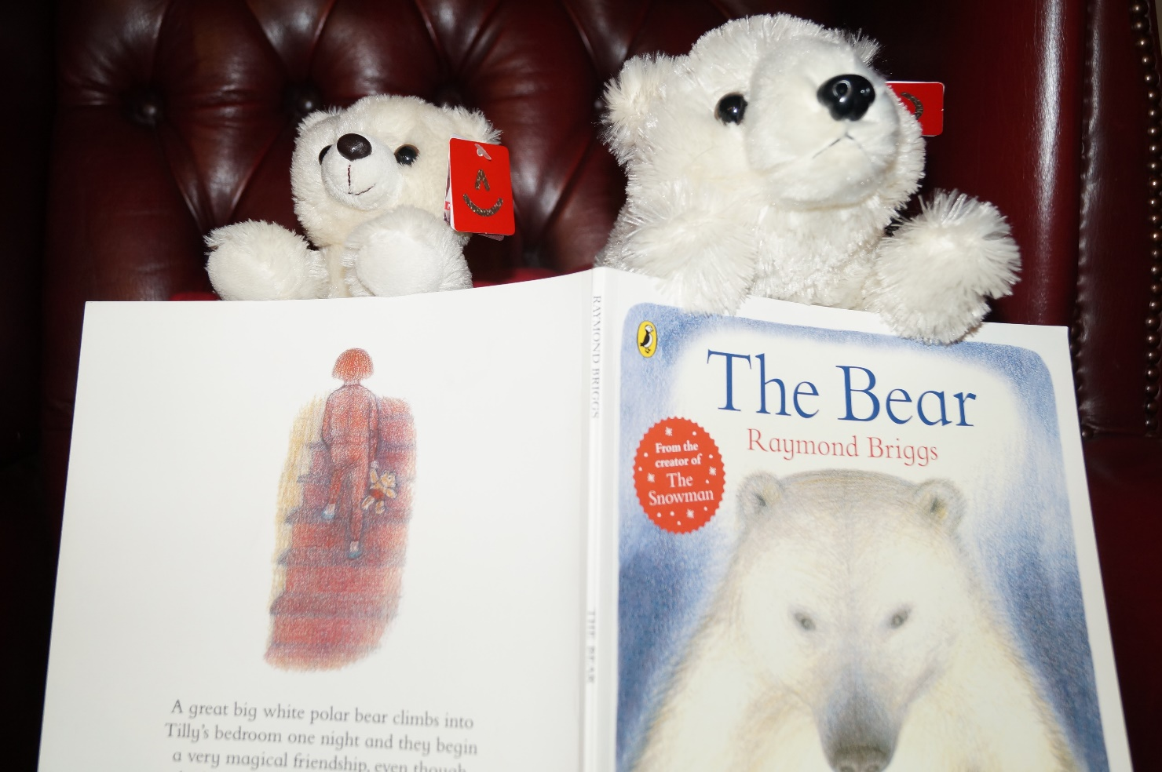

You can also visit our Gallery.
It’s a fun and relaxing space for you to chill out and explore. You could even come here during the show.

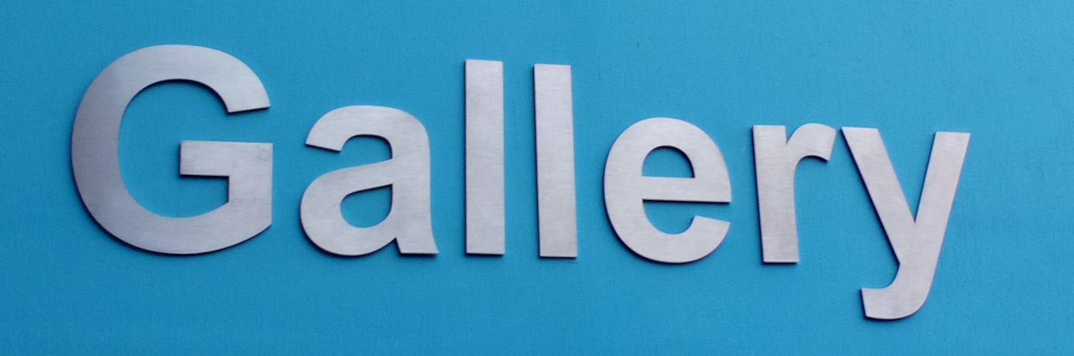

If you want to have a look around Norden Farm before coming to see The Bear you can always explore through our Google Tour.

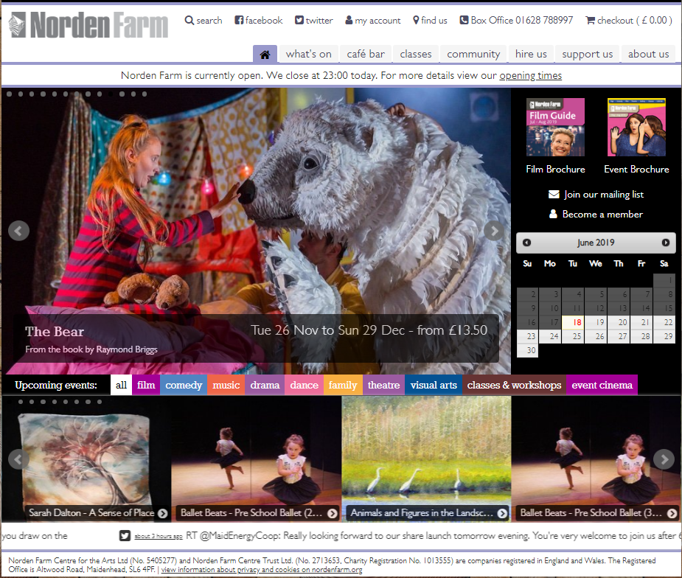
This can be found on our website, under the ‘hire us’ tab.
here

Enjoy the show

