A Basic Introduction to Clay

The intention is to spend 4 weeks to create a series of hand formed work out of clay.

We will be trying out a different technique each week and hope to have at least 4 pieces of work by the end of the course.

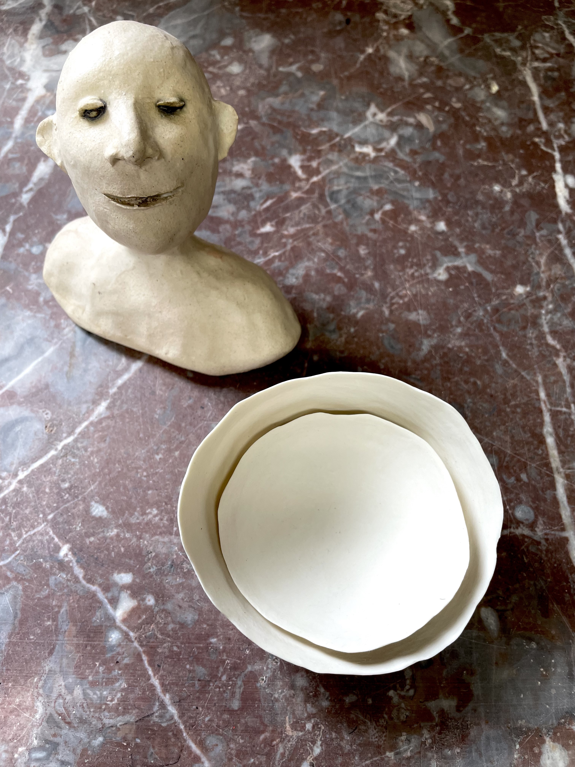
The sessions are bite size and are intended for individuals to develop their own work each week and then to carry on in their own time.

An outline of a 4 week course:

Week 1: An introduction to the basics of Pinch Pots and joining two together

Week 2: Pinch Pots and Coils

Week 3: Using coils for decoration

Week 4: Upside down coiling

Clay is included in the price. Clay packs to be collected from Norden Farm’s Café Bar on Thur 22 July & Fri 23 July, 11am-10pm.

After the course. You can arrange to have your work fired by me at an additional cost of £10, this includes a bisque firing and a glaze firing with a choice of one coloured glaze for you to decide when you drop off your work to my studio.

You will be notified via email or WhatsApp regarding the collection of your work.

You will need: A wooden board to work on approx size A4 / 20x20cm (-ish)
Newspaper
Sponge
A water pot (to wash your fingers in)
A fork and a knife
A cloth to wipe your hands on
A piece of plastic to put over your keyboard to protect it.
A plastic bag for you to store your work in - if incomplete
A clear shelf or box to store your masterpieces in, so they don’t get damaged.

Optional: An apron
Toothbrush
Water sprayer

Norden Farm / July 2021

