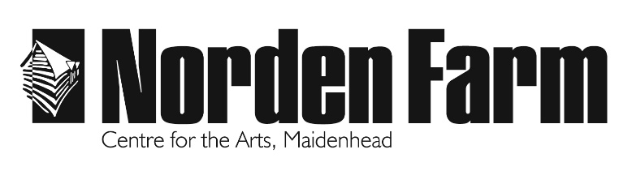
Allergy information in italics
Main Meals

6oz Beef Burger £13

Topped with monterey jack cheese gherkins with
chunky chips and baby leaf salad

( cheese; milk, bun ; wheat )
Moving Mountains ® Vegan Burger (VG ) £13
Topped with vegan cheese and gherkins with chunky
chips and baby leaf salad
( burger ; barley, bun ; wheat )
Beer Battered Haddock and Chunky Chips £13
Haddock fillet in crispy golden batter with garden peas
and a classic tartar sauce
( fish; wheat gluten, tartar sauce; egg )

Beer Battered Vegan Fish and Chunky Chips £13
Banana Blossom in crispy golden batter with garden peas
and a vegan tartar sauce
( banana blossom; wheat gluten )

Slow Cooked Ratatouille (V) £12.50
With penne pasta
( pasta; gluten )

Sweet Potato, Chickpea and Spinach Curry £13
With wild rice
( curry; mustard seed )

Boeuf Bourguignon £13
With garlic bread and salad
( bread; wheat )

Desserts
All served with a scoop of vanilla pod ice cream
Vegan ice cream available on request
Chocolate and Orange Tart £5.50
(wheat ; ice cream ; dairy )
Mixed Berry Cheesecake (GF) £5.50
( soya, milk, ice cream ; dairy )
Limoncello Tart £5.50
( wheat, milk, egg )
Vegan Sticky Toffee Pudding ( vg ) £5.50
( wheat, barley , nuts ice cream ; dairy )
Bucks Fizz Cheesecake (GF) £5.50
( oat flour, soya, sulphite, milk, ice cream ; dairy )

Sides
Chunky Chips ( wheat ) £3.50
Chunky Chips with Mature Cheddar, Salsa
and Spicy Jalapeños ( wheat , dairy ) £4.50
Garlic Ciabatta ( wheat ) £3.50
Mini Vegetable Spring Rolls with Sweet Chilli Dip £4.00
( wheat gluten, sulphite, soy bean, celery )

