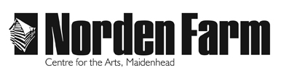
Altwood Road
Maidenhead SL6 4PF

Box Office: 01628 788997
Admin: 01628 682555
Fax: 01628 682525
Email: admin@nordenfarm.org

July 2024

Dear Applicant

Thank you so much for your enquiry regarding the vacancy of Duty Manager.
We are currently recruiting for a casual position, Tues – Sat (non-fixed/0-hour contract - includes evening work plus occasional Mondays and Sundays and potential additional hours for holiday cover and special projects).
Norden Farm is a vibrant, multi-art form venue, comprising a live event, cinema and classes programme that also facilitates private parties, commercial hires, including conferences, seminars, trade shows and meetings. Every member of the team makes a real difference to its success.
I am pleased to enclose an application pack consisting of the following:
- Job Description and Person Specification
- Equal Opportunities Monitoring Form
- Application Form

Please ensure that you read all information thoroughly before applying. Application should only be made on the enclosed application form (attaching continuation sheets where necessary), answering each section fully. CVs are not accepted. Please email applications to admin@nordenfarm.org

I look forward to receiving your application and thank you for your interest in the position.

Best wishes

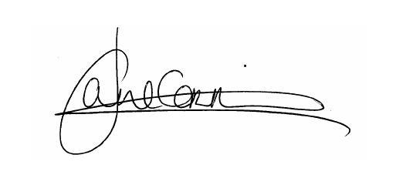

Jane Corry
Chief Executive & Artistic Director
Norden Farm Centre for the Arts

Duty Manager
Job Description

Post Title: Duty Manager

Hours: Non-Fixed Hours

Tues – Sat (includes evening work plus occasional Mondays
and Sundays and potential additional hours for holiday cover and
special projects).

Salary: £12.19 p/hr

Base: Norden Farm Centre for the Arts, Maidenhead

Reporting to: House Manager

Responsible for: Volunteers

Job Summary

The Duty Manager is responsible for managing the building on a day-to-day basis. In particular overseeing the front of house operation and working with paid staff and volunteers.

Key Responsibilities

- To manage the day to day operation of the building

- To ensure that all users of The Farm receive excellent customer service

- To manage volunteers

- To welcome visitors to The Farm and provide information as required

- To support the Box Office

- To support FOH sales including catering and retail

- To deputise for the Entertainments Licensee in her absence

Detailed Job Description

- Welcome visitors to The Farm including Audiences, Artists, Hirers, Market and Class Attenders.

- Provide show reports detailing activity and any issues arising.

- To manage the day to day running of the building

- To deliver fast, efficient ticket sales from the Box Office*

- To ensure that the foyer and public areas of the building are always kept clean and tidy.

- To manage print in the building, liaising with the marketing team

- To re-set rooms on a daily basis for classes and events. NB This includes manual lifting

- To engage in other Front of House activity including working with café bar as required

- To help with seasonal décor in the theatre foyer for school holidays and xmas

- To deputise for the Licensee in her absence, ensuring strict compliance with all conditions of the building’s Licence and undertaking regular duty management shifts

- To undertake first aid training and act as one of the venue’s nominated First Aiders

- To carry out their duties with due regard to Norden Farm’s Equal Opportunities Policy and Health and Safety Policy, and to act in accordance with the Data Protection Act

- Any other duties as may be required as part of the House Manager function

*Training on Spektrix, our computerised ticketing system will be given.

Hours of Work

Most of the work will be Tues – Sat. Occasional Sundays & Mondays in the year. Most public holidays are part of the working time and are taken as TOIL. Potential additional hours for holiday cover and special projects.

Duty Manager

Person Specification

Essential

Candidates must be able to demonstrate:

- Experience of working in sales and / or merchandising / point of sale experience
- An understanding of high-quality customer service
- A good level of physical fitness (as lifting and moving furniture to re-set rooms is required on a regular basis)
- A good level of computer literacy (training on specific software programmes will be provided)
- A keen eye for detail
- Excellent communication skills, both written and verbal
- Ability to work unsupervised and as part of a team
- Excellent organisational skills
- A genuine interest in the arts

Desirable

- Duty management experience in a similar environment
- Experience of working in a Box Office, particularly operating Spektrix
- Own means of transport
- First Aid qualification

Norden Farm uses Spektrix for box office ticketing, and Microsoft Office for administrative purposes.

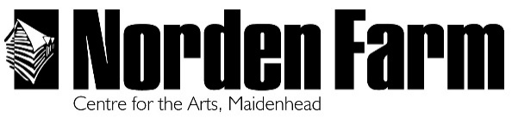

CONFIDENTIAL

Please read the job description and supporting information before completing this form.

Please complete this form, ensuring you fill in all appropriate sections as fully as possible. Forms may be completed electronically or by hand in black ink. CVs should NOT be included with applications. There are 5 pages plus a separate Equal Opportunities Monitoring Form.

Completed application forms may be submitted by email to admin@nordenfarm.org or by post to: Norden Farm Centre for the Arts, Altwood Road, Maidenhead, SL6 4PF.

If you have a disability or any other special need that means you are unable to complete this form or any other part of the process, please contact us to make alternative arrangements.

We will keep your application form on file for 3 months after the date of receipt.

Application for the post of:

Personal Details

Last Name
First Names
Home Address
 |  |  | Postcode
Telephone | Home |  | Work
 | Mobile
Email address
May we contact you at work?

Education and Training

Secondary Education
From | To | School(s) |  | Examinations passed/Grades
Higher and Further Education (University/College/Apprenticeships etc)
From | To | Place of Education |  | Qualifications obtained
Short and Part-time Courses (including relevant in-house training)
Dates |  |  | Details

Previous Employment

Date from | Date to | Name, location and nature of employer’s business |  | Position held | Reason for leaving

Supporting Information

Please use this space to tell us why you have applied for this position and what you will bring to the post. Reference the Job Description. Describe how the skills and experience you possess would enable you to fulfil the role as described in the job description and any other information that supports your application. Use a continuation sheet if necessary.

Further Information

Do you hold a current and full (not provisional) EU driver’s licence?
Do you require a work permit to work in the United Kingdom?
Please state how many days you have been absent from work/college due to illness during the last two years, providing details for any extended absence if you wish.*
Under the Rehabilitation of Offenders Act 1974, candidates are not usually required to give details of spent offences
Have you ever been convicted, cautioned, bound over or have a conviction pending in respect of any criminal offence which is not considered spent? *
* Please use an additional sheet if necessary

References

Please give the names and addresses of two people, not relatives, one of who should be your current employer (or last employer) from whom confidential references may be obtained. It is Norden Farm’s policy to contact referees before an offer of employment is made. Please indicate if you would prefer this NOT to happen.
Name | Position | Address/Telephone Number/Email

Declaration

I declare that the information on this application is, to the best of my knowledge, true and complete

Signed | Dated

