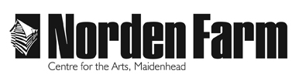
Altwood Road
Maidenhead SL6 4PF

Box Office: 01628 788997
Admin: 01628 682555
Email: admin@nordenfarm.org

How do our online Youth Theatre classes work?

The classes will take place via a video stream on Zoom where you'll be able to use the camera and audio on your tablet, laptop or other device to see and hear the tutor and other participants.

I am sure you will all appreciate that we want to ensure that we are providing a safe online space for all our participants. Security procedures are in place to ensure the learning environment is safe and secure.

These include:

- A unique password for each lesson
- Recording feature is disabled
- Student screen sharing is disabled
- Group Leader controls who can enter from the Zoom Waiting Room
- Group Leader can remove anybody from the lesson at any time
- Virtual backgrounds disabled

How to get online

Once you have booked your place via our Box Office and signed and returned the code of conduct and registration form we will send you an email with a link to your first session, password and a meeting ID.

A new link will be sent out before each week’s session for safeguarding purposes, so keep an eye on your emails.
Please do not share these links with anyone (including people who are in the group). All links will be directly sent to all participants.

If you'd like to learn more about joining a meeting on Zoom, click here (https://support.zoom.us/hc/en-us/articles/201362193-How-Do-I-Join-A-Meeting-) for a handy guide.

