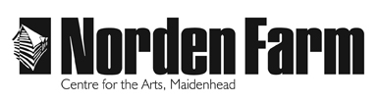

Classes and Activities – Information Sheet

Life Drawing - SPR2018

Category: Adult (18+)

Dates: Sat 13 Jan, 10 Feb and 10 Mar

Day: Saturday

Time: 2pm – 5pm

Location: Norden Farm

Tutor: Harriet Brittaine

Class Size: Up to 13

Cost of class: £25

Information about the class:
Explore the complexities of the human form by working from a professional life model. With a variety of short and long poses, learn both traditional charcoal drawing methods and new experimental techniques!

Materials or clothing required and any additional costs:
Materials are included; please note it is advisable to wear old clothing.

Tutor biography:
Harriet Brittaine is a professional artist and teaches life drawing, oil painting and portraiture across Berkshire. She has taught in the UK and abroad, and is Co-Director of the local and award-winning social enterprise Art on the Street.

To book please contact: Box Office on 01628 788997 / www.nordenfarm.org

Norden Farm Centre for the Arts Ltd. (No. 5405277) & Norden Farm Centre Trust Ltd. (No. 2713653, Charity Registration No. 1013555) are companies registered in England and Wales. The Registered Office is Altwood Road, Maidenhead, SL6 4PF.

