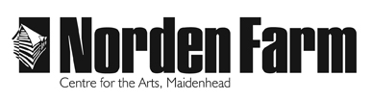
Classes and Activities – Information Sheet

Portrait Drawing – AU2019

Category: Adult (18+ years)

Dates: Sat 2 Nov 2019

Time: 10am – 3pm

Location: Norden Farm Centre for the Arts

Tutor: Chris Bryant

Class Size: 13

Cost of class: £34

Information about the class:
Learn about the stages of portraiture, drawing with charcoal from a live model. Students are taught about proportion, the structure of the head, and tonal values. Experiment with creating contrast between light and dark (chiaroscuro) to depict facial features. Suitable for all levels of experience.

Materials or clothing required and any additional costs:
Materials are included; please note it is advisable to wear old clothing.

Tutor biography:
Chris’s practice focuses on figure, manipulation and viewer authorship. It is the narratives that the audience create that motivates him to produce. He likes to explore his work through practice and studies, allowing the process to develop naturally. Allowing him to discover new and exciting methods to produce work.

To book please contact: Box Office on 01628 788997 / www.nordenfarm.org

Norden Farm Centre for the Arts Ltd. (No. 5405277) & Norden Farm Centre Trust Ltd. (No. 2713653, Charity Registration No. 1013555) are companies registered in England and Wales. The Registered Office is Altwood Road, Maidenhead, SL6 4PF.

