Self Portrait using Collage
Fri 22 Jan – Fri 12 Feb, 3.30pm-4.30pm
£8 per session or £28 for 4-weeks
Max cap 15
Led by Helen D Evans

The intention is to encourage a sense of self discovery by exploring your identity through the art of collage.

Each week we will focus on different areas of the face trying out alternative ways to use collage.

An outline of a 4 week course:

Week 1: 10 interesting things about me.
Creating quick collages by cutting out features from magazines.
Focusing on the nose using cut outs and drawing.
Consider using your own photos as part of the collage.

Week 2: Find a quote that relates to you - you may decide to include this in your collage.
Looking at the mouth - ripping paper.

Week 3: Things that make up who I am.
The eyes - using a mosaic effect

Week 4: Compiling your Self Portrait using solid colour / patterned back grounds.
This will be your base to then add your features on.

Participants to provide own materials:
Collage is a very flexible and minimal art form as you can use anything within reason - it is perfect for recycling a pile of old magazines and newspapers, you can use old photos or print outs.

Other basic materials: a mirror, glue, scissors, paint is optional.

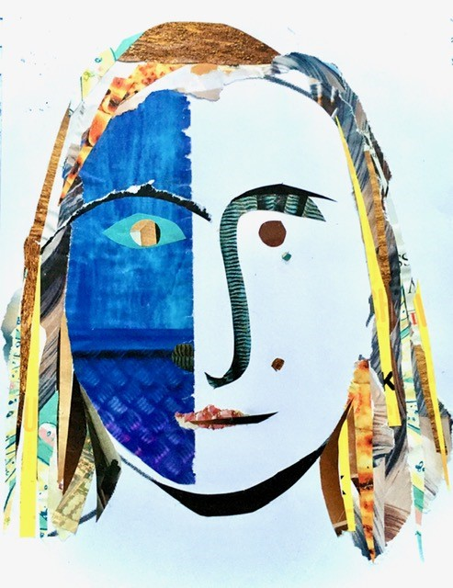
You will need one large piece of paper and some sheets that are A6.

Helen d Evans Dec 2020.
Artist / Facilitator / Educator

