Block 6
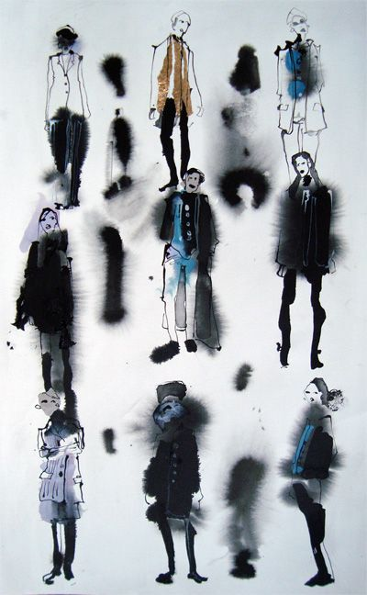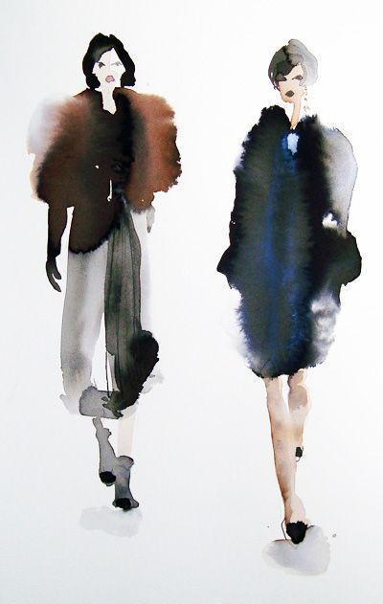
Artist Bridget Dawson inspired fashion figure paintings, loose and inky. Indian ink and pen
Materials: watercolour paper 300gsm, Indian ink, HB pencil, watercolours or gouache paints, brushes, eraser,
From home: Black fine line tip, & or biro pen, water pots x 2 paint brushes, loo role, images printed off

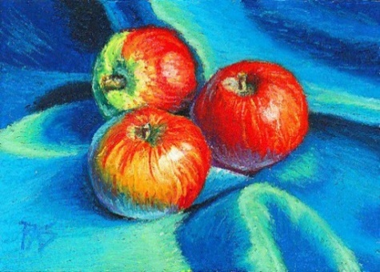
Vibrant still life apple and fabric study chalk pastels
Materials: two sheets of blackpaper or sugar paper, HB pencil, white chalk pencil, soft chalk pastels, blending tool.
From home: loo role, cotton buds, hairsprey, images printed off
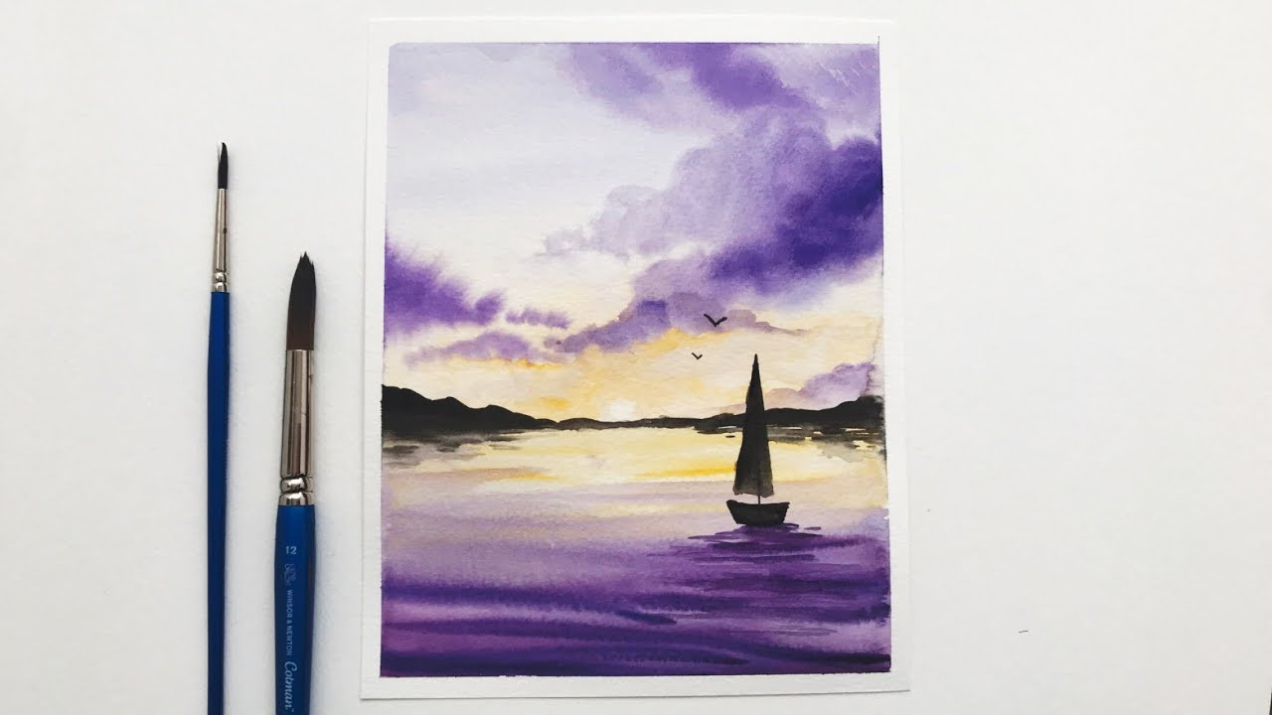
Violet tints, tones and shades sea scape watercolours wet on wet
Materials: watercolour paper 300gsm, watercolour or gouache paints, HB pencil, brushes, eraser, masking tape.
From home: water pots x 2 paint brushes, loo role, images printed off

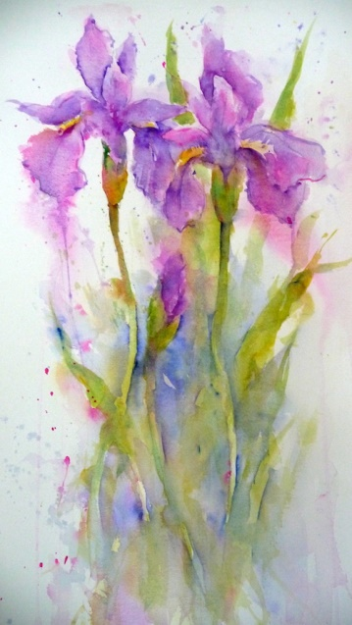
Iris Study Loose style Watercolours
Materials: watercolour paper 300gsm, watercolour or gouache paints, HB pencil, brushes, eraser, masking tape.
From home: water pots x 2 paint brushes, loo role, images printed off

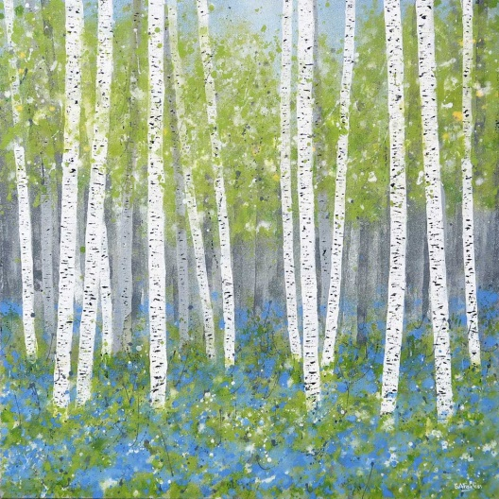
Silver Birch wood Mixed media and cut paper
Materials: watercolour paper 300gsm, watercolour or gouache paints, HB pencil, brushes, eraser, masking tape.
From home: water pots x 2 paint brushes, loo role, images printed off

Block 8
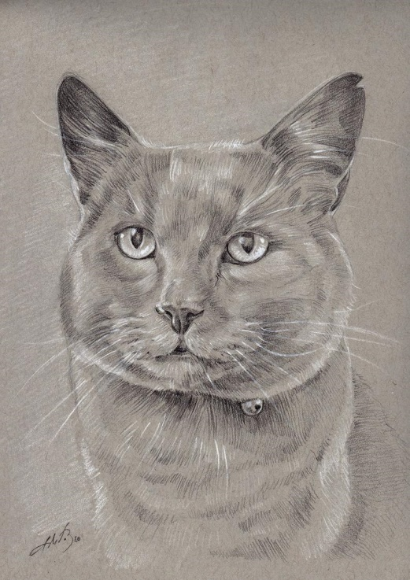
Monochromatic Car portrait sugar paper, HB, 2B, 4B pencil and white chalk pencil
Materials: One sheet of preferabley grey sugar paper, colouring pencils, HB pencil, white chalk pencil eraser, From home: water pots x 2, loo role, images printed off

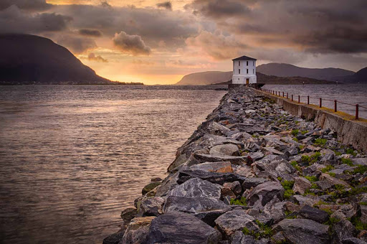
One point perspective Lighthouse on Rocks Mixed media
Materials: watercolour paper 300gsm, watercolour or gouache paints, HB pencil, brushes, eraser, masking tape, Indian ink, charcoal, chalk pastels, colouring pencils
From home: water pots x 2 paint brushes, loo role, images printed off

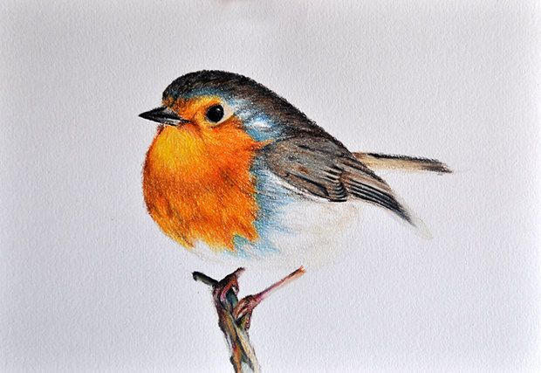
Robin study coloured pencils and watercolour
Materials: brushes, watercolour paper 300gsm, watercolour paints or gouache paints, HB pencil, colouring pencils, eraser, paint brushes.
From home: water pots x 2, loo role, images printed off

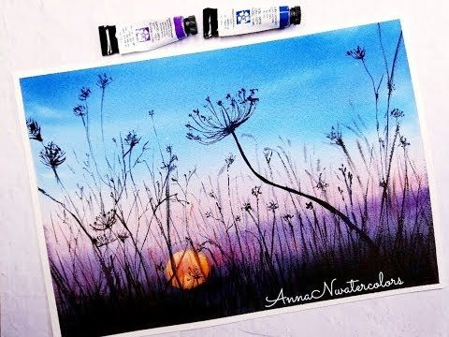
Sunrise, with cowslip. Watercolour wet on wet, ink and pen
Materials: watercolour paper 300gsm, watercolour or gouache paints, HB pencil, brushes, eraser, masking tape, Indian ink, charcoal, chalk pastels, colouring pencils
From home: black fine finer pen, water pots x 2 paint brushes, loo role, images printed off

