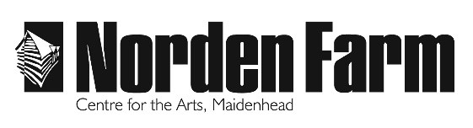
Youth Theatre
Covid-19 Additional Guidelines
Friday 11 September 2020

This information is issued an addition to our regular registration form.
By competing and returning the registration form you confirm that you and your young person have read and understood the additional guidelines in place in line with Norden Farm’s Covid-19 Policy.
If you have any questions, please don’t hesitate to get it touch.
Kind regards,
Robyn Bunyan
Education Manager
Face Coverings
Public Health England does not (based on current evidence) recommend the use of face coverings when children are participating in out-of-school settings activities.
Children aged 11+ years should wear a face covering around the public areas of the building, and on arrival and departure. Face coverings can be removed when in the workshop space, and not worn during the session.

General Building Guidance
- All high-volume areas within the venue will be sanitised throughout the day
- There are visible floor markers and signage to encourage social distancing
- There are one-way routes around the building to decrease contact with other customers

Arrival and before the class begins
- There are sanitiser stations at each public entrance and throughout the building. Please sanitise your hands as soon as you arrive
- Within the workshop space there will be hand sanitiser for participants to use on arrival and during the session
- To reduce contact between parents and carers when dropping off and picking up your children please be mindful and, where possible, limit drop off and pick up to one parent or carer per family
- Please arrive at the drop off time slot and location, do not congregate by the workshop venue doors
- Our tutors will collect the participants from the Arrival Drop Off Location

When the class ends
- Participants can be collected at the end of the class from the Departure Collection Location
- Our tutors will bring the group to the Pickup Location

Youth Theatre Senior 1
Wednesday | 4.15pm – 5.45pm
Arrival Drop Off Slot: 4pm – 4.15pm
Arrival Drop Off Location: seated at tables in Nordens
Departure Pick Up Slot: 5.45pm

Youth Theatre Senior 2
Wednesday | 6pm – 7.30pm
Arrival Drop Off Slot: 5.45pm – 6pm
Arrival Drop Off Location: seated at tables in Nordens
Departure Pick Up Slot: 6pm

