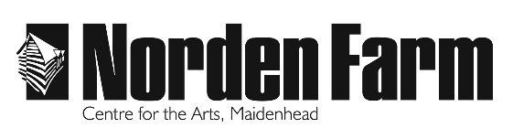
Photo / Video Consent Form
Across the term, during workshops, sharing and performances Norden Farm Centre for the Arts and / or youth group practitioners may welcome professional photographers, the press or staff into the session to take photos and /or videos.
Sharing photos and videos is one of the best ways to inspire others to get involved with and share the achievements of participants of Youth Theatre so we would be grateful if you could read the below information and sign and return the below photo consent form.
If you have any questions about this form please contact Box Office (boxoffice@nordenfarm.org)
Photo Permission
By signing this form, you agree that Norden Farm and / or photographers employed by Norden Farm and / or youth group practitioners and / or the press may photograph / video your child and publish the materials, along with their full name, in the press, on social media platforms and in marketing materials including, but not limited to, brochures, flyers, adverts and banners. Norden Farm Centre for the Arts and / or youth group practitioners and / or photographers employed by Norden Farm and / or the press will have full rights to use the images resulting from the photography / video filming, and any reproductions or adaptations of the images for the purposes laid out above.
Name of child
(as listed on the registration form)
Group Name
Name of parent / guardian
Signature of parent / guardian
Date

Data Protection
Norden Farm will hold this information indefinitely on a secure network. We will never share this information to third parties without your consent. You have the right to withdraw photo consent at any time by emailing admin@nordenfarm.org Should you withdraw consent Norden Farm cannot use the relevant images again, but it is not possible to recall documents in which their image has already appeared

