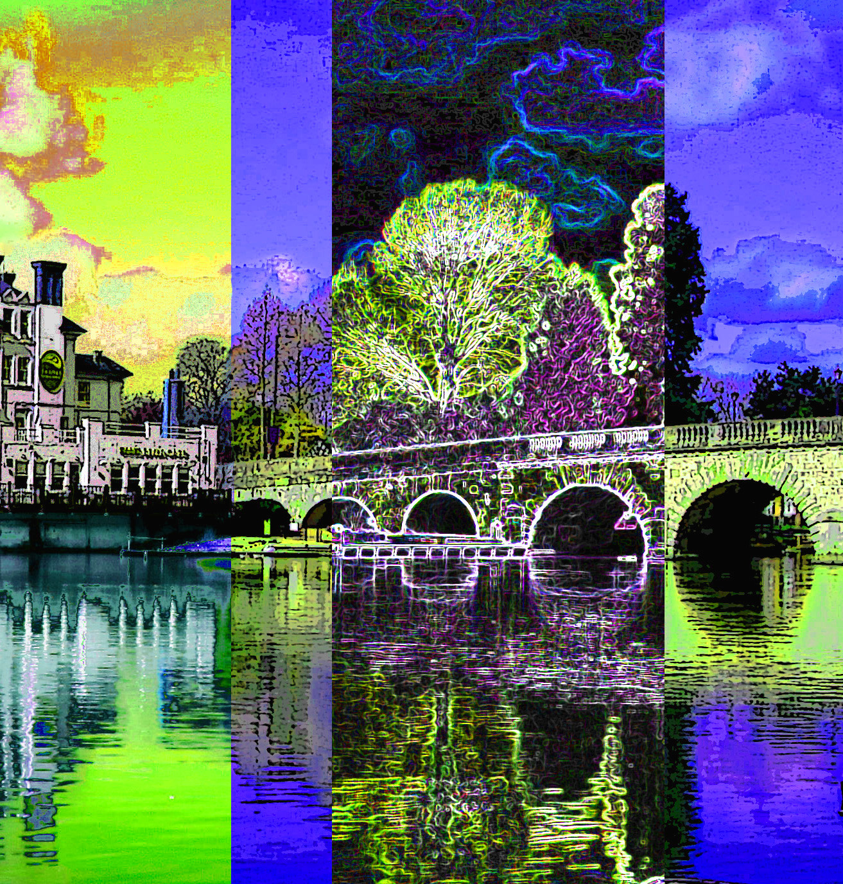

The Arts Society Maidenhead, a member society of The Arts Society

The Society provides an exciting programme of monthly lectures for members usually on the third Monday of the month, covering a wide range of subjects. The speakers are all engaging communicators, who excel in their field. The Society offers enjoyable opportunities to discover and support the arts of yesterday, today and tomorrow and to make new friends in convivial surroundings.

Lectures take place in the Courtyard Theatre at Norden Farm. This splendid venue has a huge display screen and excellent acoustics. The Maidenhead Society has now been running successfully for a year, with fascinating monthly lectures and several additional events, notably ‘In and Around St Pancras’, a London walk led in September by Andrew Davies.

There is an exciting new programme planned for next year. Our membership of 250 comes from Maidenhead and the surrounding area. To enquire about membership or to attend a lecture as a guest, please email maidenhead@theartssociety.org

Monday 12 November - Jo Walton - A Family Affair: Florence and The House of Medici
11.30am Norden Farm
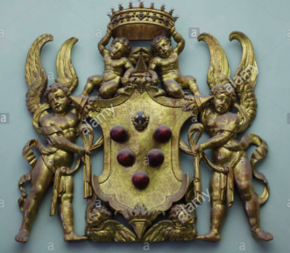

The names 'Florence' and 'Medici' go together. From the late 1300s to 1737, the Medici family was an integral part of the world of Florence. They advised, ruled, were exiled, returned, ruled again - in continuing cycles - eventually stamping their authority on the city with autocratic firmness. At the same time, they supported and patronised painters, sculptors and architects, beautifying the city and bringing it lasting renown as a place of cultural excellence. This is a story full of amazing characters and stirring historical events all set against the backdrop of one of the most vibrant and artistic centres of the Renaissance.
Profile
Jo Walton combined teaching and lecturing with a career in art bookselling. She set up and ran the Atrium Bookshop in Cork Street – the heart of London’s art world – and worked with Christie’s. She now combines freelance lecturing with work in publishing and guiding at Tate Modern and Tate Britain

Monday 21 January – AGM
Andrew Prince – From Downton to Gatsby: Jewellery and Fashion 1890-1929

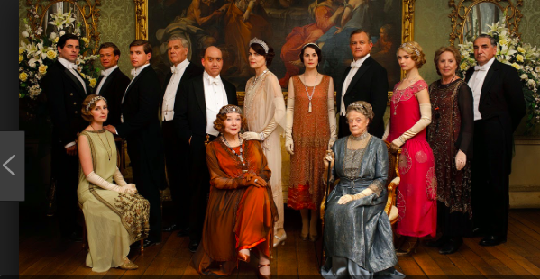

For the series Downton Abbey, Andrew was commissioned to produce many jewels for the main characters, and this inspired him to create a talk based on Downton and the changing styles of the time portrayed.
Jewellery and Fashion are often seen as two entirely separate and distinct fields of design, but this is very far from the case.
In his talk, Andrew guides you through the extraordinary periods and events between 1890 and 1929, where the great fashion houses collaborated with the finest of jewellers to produce works of art of outstanding quality and glittering opulence. Along with this he discusses the clients and patrons who commissioned the jewels and how they were worn with the sumptuous gowns.

Profile
Andrew Prince has had a passion for jewellery since he was a small child. When only nine, his mother took him to the Princely Magnificence exhibition at the V&A. It proved a revelation and Andrew decided then and there that creating jewellery was what he wanted to devote his life to. At sixteen, he started work in London’s Bond Street, working for The Antiques Roadshow expert Ian Harris. Under his guidance, he developed an appreciation for jewels that were valued for their quality of design and craftsmanship, rather than for how much the stones in the piece were worth. Soon Andrew began undertaking private commissions and celebrities were seen wearing his creations. In 2005, he was asked to make tiaras and jewellery for Mrs Henderson Presents. In 2009, pieces were commissioned for The Young Victoria and in 2012, he was chosen by the creators of Downton Abbey to supply a large collection of jewellery for the third series.

Monday 25 February
Alexandra Epps – John Piper: Master of Diversity

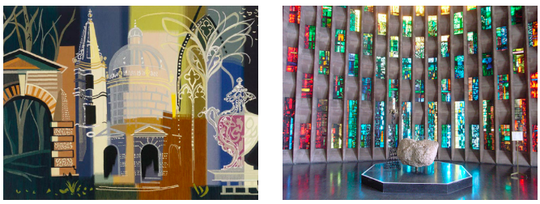

From cathedrals to churches, cottages to coastlines we are never very far from a place John Piper has painted, written about or undertaken a commission for. One of the most versatile British artists of the twentieth century - painter, designer, stained glass artist, photographer and writer on the arts - a man of many parts, truly a master of diversity.
For most of his adult life John Piper lived at Fawley Bottom, near Henley. Recently a permanent exhibition celebrating his work has been established at the River and Rowing Museum in Henley.

Profile
Besides being an accredited Arts Society Lecturer, Alexandra Epps is also a guide at Tate Modern and Tate Britain and a Pallant House lecturer. She is a Freeman of the City of London and an official guide. Her background is in design, having practised as a graphic designer running her own design consultancy for many years.

Monday 18 March
Paul Roberts – Life and death in Pompeii and Herculaneum
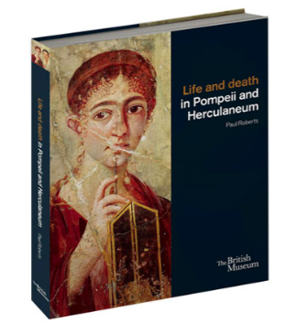 | 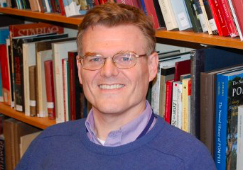

In this lecture, Paul explores the lives of the ordinary people of Pompeii and Herculaneum, the two cities on the Bay of Naples that were buried by the catastrophic volcanic eruption of Mount Vesuvius in AD 79. The plaster-cast bodies of the victims are the most vivid shocking reminders of the horrific event that made Pompeii famous, but who were these men, women and children so cruelly frozen in time? Exploring striking new discoveries and artefacts, Paul brings the inhabitants of Pompeii and Herculaneum back to life from the ashes and ruins of their own homes.

Profile
Dr Paul Roberts is the newly appointed Sackler Keeper of Antiquities at the Ashmolean Museum, Oxford University. From 1994 to 2014 he was Senior Roman Curator in the Department of Greece and Rome at the British Museum, where he was the driving force behind the major exhibition Life and Death in Pompeii and Herculaneum. Paul’s research focuses on the day-to-day lives of ordinary people in the Greek and Roman worlds. He is currently writing a walking tour of Ancient Rome.

