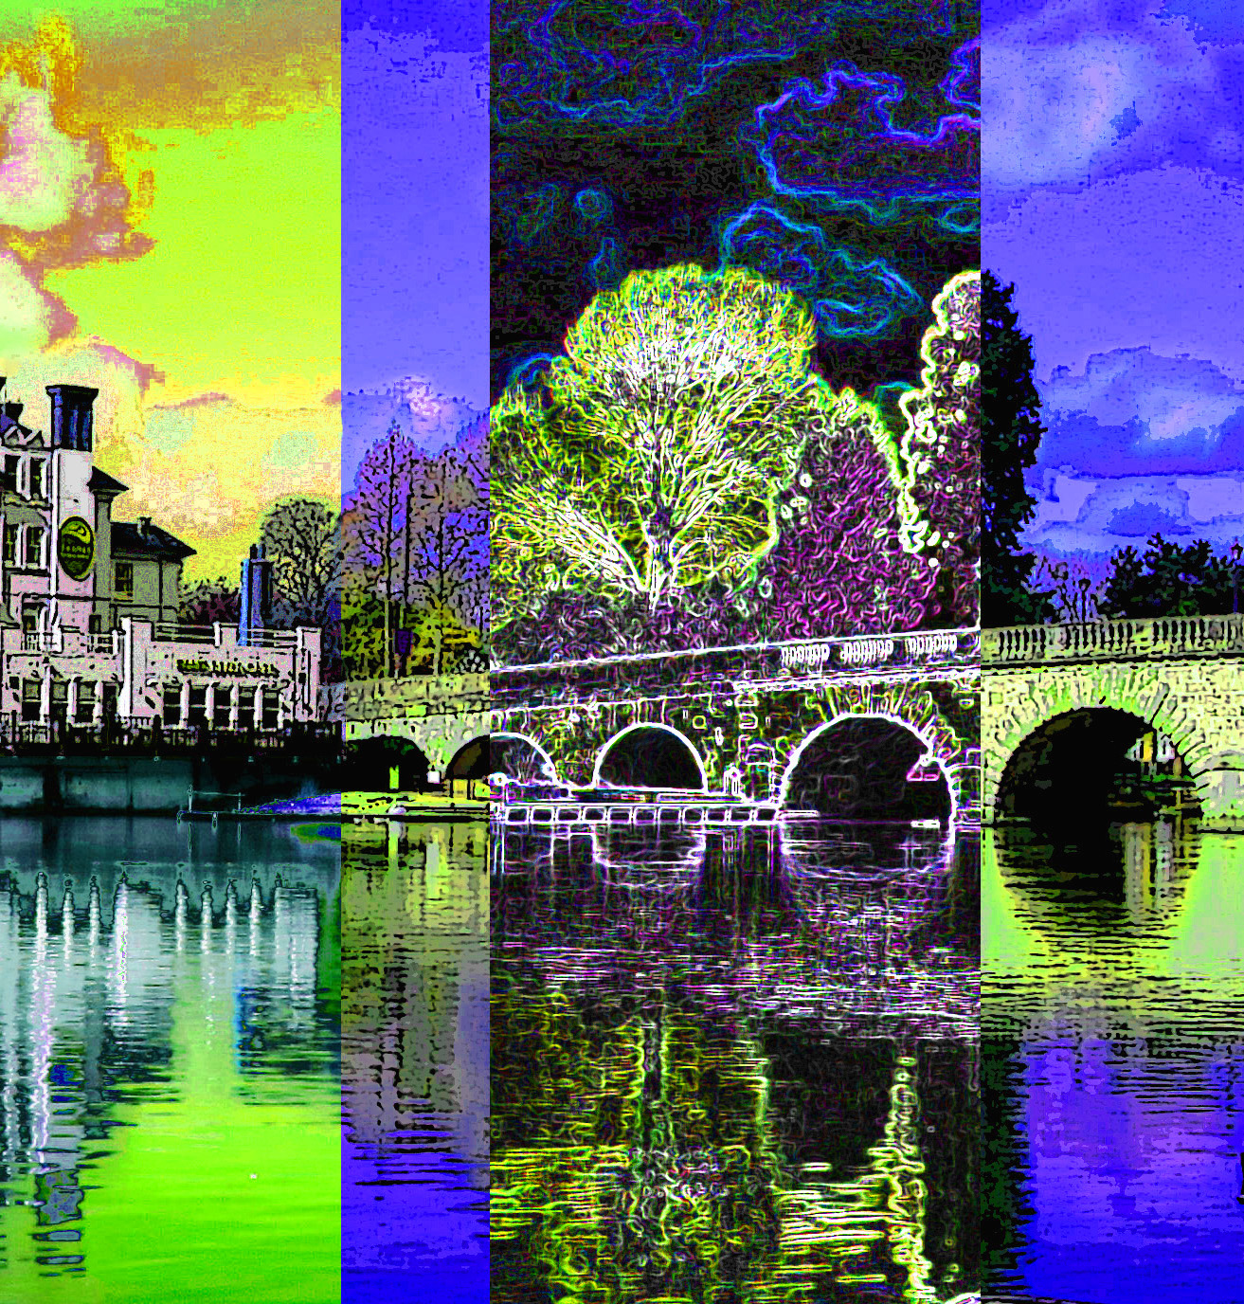

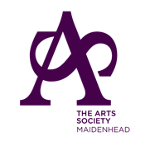

The Arts Society Maidenhead, a member society of The Arts Society

The Society provides an exciting programme of monthly lectures for members usually on the third Monday of the month, covering a wide range of subjects. The speakers are all engaging communicators, who excel in their field. The Society offers enjoyable opportunities to discover and support the arts of yesterday, today and tomorrow and to make new friends in convivial surroundings.

Lectures take place in the Courtyard Theatre at Norden Farm. This splendid venue has a huge display screen and excellent acoustics. The Maidenhead Society has now been running successfully for a year, with fascinating monthly lectures and several additional events, notably ‘In and Around St Pancras’, a London walk led in September by Andrew Davies.

There is an exciting new programme planned for next year. Our membership of 250 comes from Maidenhead and the surrounding area. To enquire about membership or to attend a lecture as a guest, please email maidenhead@theartssociety.org

____________________________________________________________________

Monday 18 March
Paul Roberts – Life and death in Pompeii and Herculaneum
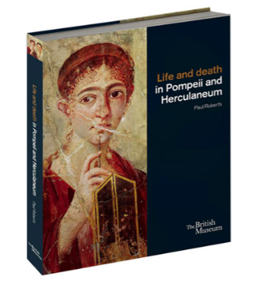 | 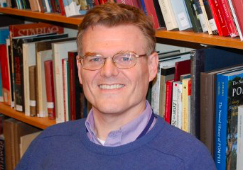

In this lecture, Paul explores the lives of the ordinary people of Pompeii and Herculaneum, the two cities on the Bay of Naples that were buried by the catastrophic volcanic eruption of Mount Vesuvius in AD 79. The plaster-cast bodies of the victims are the most vivid shocking reminders of the horrific event that made Pompeii famous, but who were these men, women and children so cruelly frozen in time? Exploring striking new discoveries and artefacts, Paul brings the inhabitants of Pompeii and Herculaneum back to life from the ashes and ruins of their own homes.

Profile
Dr Paul Roberts is the newly appointed Sackler Keeper of Antiquities at the Ashmolean Museum, Oxford University. From 1994 to 2014 he was Senior Roman Curator in the Department of Greece and Rome at the British Museum, where he was the driving force behind the major exhibition Life and Death in Pompeii and Herculaneum. Paul’s research focuses on the day-to-day lives of ordinary people in the Greek and Roman worlds. He is currently writing a walking tour of Ancient Rome.

____________________________________________________________________
Monday 29 April
Ian Keable – One Hundred Years of Deception: Hoaxes and Swindlers in 18th Century

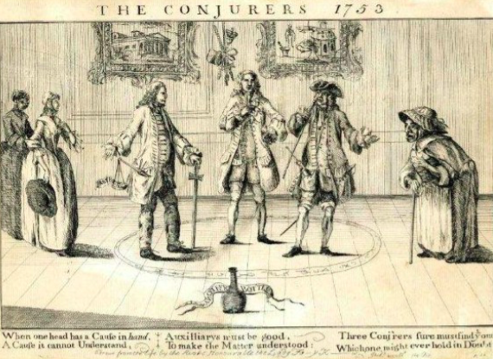

The 1700s was a period when the people of England seemed to be especially gullible. Quite understandable perhaps that they believed William Ireland’s claim that he had found a missing Shakespeare play called ‘Vortigern’; or that Milton had plagiarised contemporary poets to write ‘Paradise Lost’: think of how many people fell for the supposed discovery of Hitler’s diaries. But believing a woman could breed rabbits; a man could climb into a two-pint bottle and sing and dance inside it; and a balloonist could fly in a Chinses temple, were surely evidence of extreme credulity. These, and other hoaxes – which involved the likes of Jonathan Swift, Samuel Johnson and the politician Charles James Fox – were written about in newspapers and journals and brilliantly and amusingly depicted by satirical artists such as William Hogarth and James Gillray. In this entertaining talk, Ian relates and illustrates sundry hoaxes and deliberate deceptions; all of which are memorable not only for the imaginative nature of the swindles, but also because of the differing motives of the tricksters.

Profile
Ian graduated from Oxford University in Politics, Philosophy and Economics, qualified as a Chartered Accountant and then became a professional magician. He is an accredited lecturer for The Arts Society and a Member of the Inner Magic Circle. Ian divides his time between performing magic, giving talks and researching and writing.
__________________________________________________________________________________________

Monday 20 May
Charles Harris – ‘Mind the Gap’: Graphics and designs for the London Underground

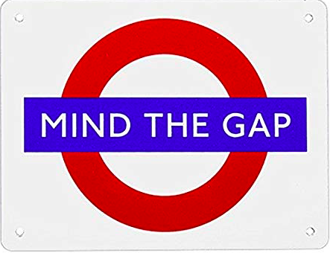

‘Mind the Gap’ examines the world-beating graphics, designs and posters created for the London Underground. From early days through the inventive inter-war years, this lecture is rammed with well-known artists and great stories. Many of the world’s cleverest graphic designers have worked for the London Underground and still do!
Profile
Charles Harris has had a life-long career in advertising around the world, most of it as a Creative Director. He has been responsible for the quality of the creative ideas and finished production of work for great brands including BA, Sony, Nestle, Shell, Heinz, Black & Decker, Gilette and McDonalds and earned global awards across the world, from New York to Singapore and Sydney. His experience gives a unique insight into what works, what doesn’t and why.

This lecture has been sponsored by Woodlands Dental Practice.
__________________________________________________________________________________________

Monday 17 June
Denise Heywood – Shimmering Splendour: Silk in South-East Asia

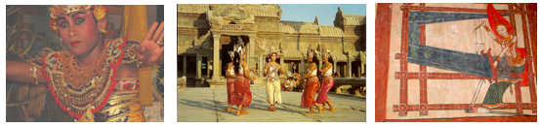

Luxurious, sumptuous silk, beloved of kings and courts, priests and princesses, is a miracle of nature. The thread of silkworms, woven into fabric, a process guarded in China when discovered, became so valuable it was a source of currency. This sensual material, created in countries from Cambodia, Laos and Vietnam to Thailand, Burma, Bali and Philippines, embellishes all who wear it. But its origins were sacred, a gift from the gods, to cover holy manuscripts, adorn sacred dancers in rituals and protect wearers with auspicious symbols.

This lecture shows the origins of silk, most dazzling of all natural creations, revealing its transformation from silkworm cocoons, dyed and woven in glorious colours and complex patterns. Images of sartorial splendour, glamorising handsome film stars, ennobling monarchs at royal courts and enhancing dancers’ ethereal beauty in Hindu temples, illustrate how human and divine forms have been enriched by this shimmering material.

Profile
Denise Heywood is an art historian, author, lecturer, photographer and journalist. She worked in Cambodia in the 1990s and has been a scholar of Southeast Asian art since then. Now based in London, she is a lecturer for The Arts Society, The Art Fund and The School of Oriental and African Studies, University of London. She has lectured all over the world at universities, colleges, schools, travel societies, art institutions and on cruise ships. She writes for many art, literary and travel publications and has appeared on television and radio.

__________________________________________________________________________________________

Monday 16 September
Caroline Shenton – Packing up the Nation
(Sending art collections to safety prior to the outbreak of World War II)

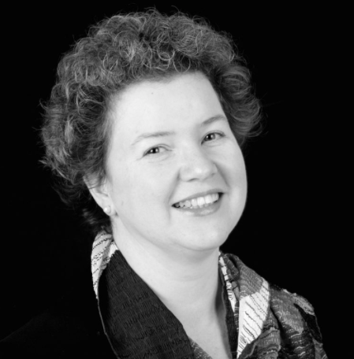
As Hitler’s forces gathered on the other side of the Channel to threaten these islands, men and women from London’s national museums, galleries and archives forged extraordinary plans to send their collections to safety. Utilising country houses from Buckinghamshire to Cumbria, tube tunnels, Welsh mines and Wiltshire quarries a dedicated team of unlikely heroes packed up their greatest treasures in just a few weeks during the sweltering summer of 193, despatching them throughout the country on a series of wartime adventures. In her lecture, Caroline Shenton tells what happens next.

Profile
Dr Caroline Shenton is an archivist and historian. She was formerly Director of the Parliamentary Archives in London, and before that was a senior archivist at the National Archives. She has written a number of popular history books including ‘The Day Parliament Burned Down’ and ‘Mr Barry’s War’. Caroline teaches Public History to postgraduates at the University of Dundee, and during 2017 was a Political Writer in Residence at Gladstone’s Library.

_________________________________________________________________________________________

Monday 21 October
John Stevens – Imperial Calcutta: Art and Architecture

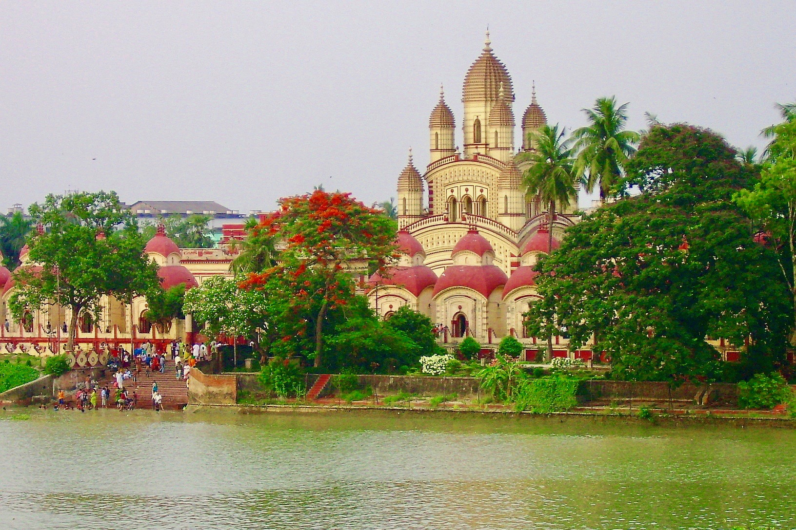

Calcutta was second city of the British Empire and a hub of cultural and artistic production throughout the nineteenth and twentieth centuries. This lecture looks at the arts and architecture of this extraordinary city, which was India’s capital until 1911. Calcutta played a central role in shaping the culture of modern India, as its artists sought to interpret India’s classical heritage in new ways, and to combine this heritage with Western cultural forms. We will examine how Calcutta became the epicentre of the ‘Bengal renaissance’ and how the city’s artists viewed (and were affected by) British rule.

Profile
Dr John Stevens is a Research Associate at SOAS, University of London, and a member of academic staff at the SOAS South Asia Institute. His PhD in History is from University College London. He teaches British Imperial history, Indian history and Bengali language, and is a regular visitor to India and Bangladesh. His biography of the Indian guru Keshab Chandra Sen was published in 2018. He appears regularly in the Indian media and was recently a guest on BBC Radio Four’s In Our Time.

