THE ARTS SOCIETY MAIDENHEAD 2020 LECTURES
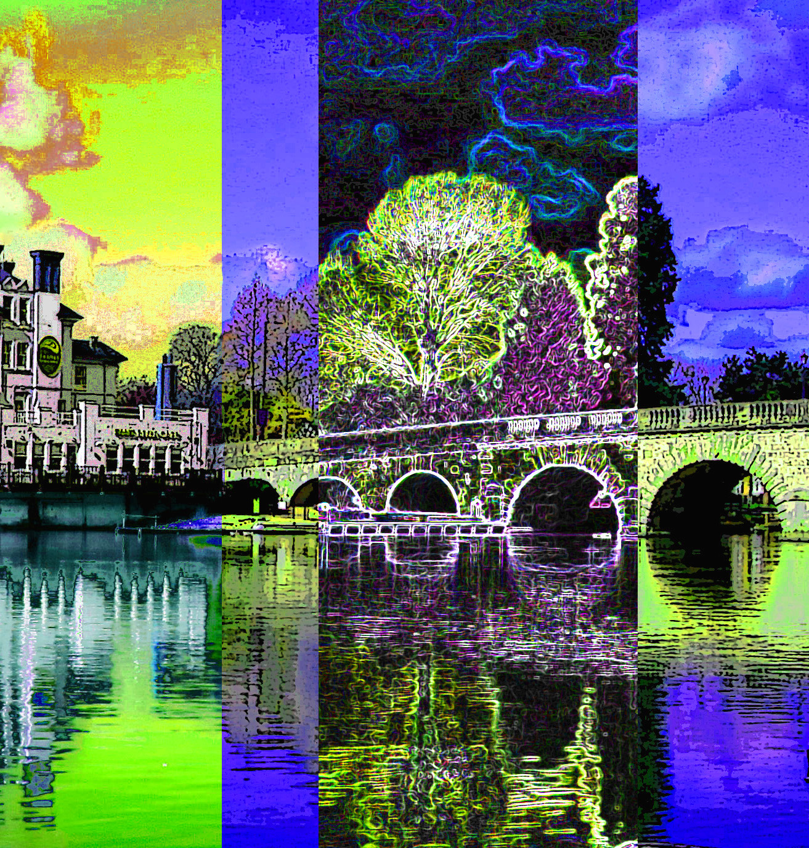

Monday 11 November (Date to be confirmed)
Ian Swankie – From Bronzes to Banksy: an armchair tour of public art and street art

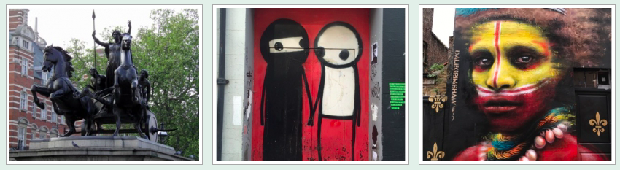

London has a world-class reputation for art in its many galleries, but this is a talk about the remarkable range of art outside in the streets. We tour around the capital discovering some of the most interesting works. They range from huge and expensive commissions to unofficial graffiti, which is sometimes audacious and often playful, but they all have a place in our society. In his talk, Ian looks at why art is there, how it has developed over the years and discovers many hidden gems.

Profile
Ian Swankie is a Londoner with a passion for art and architecture. He is an official guide at Tate Modern, Tate Britain, Guildhall Art Gallery and St Paul’s Cathedral. He is also an active freelance guide for The Arts Society, WEA, Transport for London, the National Trust and London Open House. Five years ago, he established a weekly independent art lecture group in Richmond.

Monday 20 January
Cleopatra: The Most Womanly of Women and the Most Queenly of Queens’
Lucy Hughes Hallett

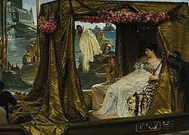

Cleopatra, for whom Antony is imagined to have given up the chance to rule the Roman world, has been inspiring painters, poets and film-makers for over two millennia. Their voluptuous depictions of her show the changing concepts of beauty, and the racial and sexual assumptions underlying them. Images range from Roman to Renaissance to 20th century film stars such as Vivien Leigh, Elizabeth Taylor and the Carry On team’s Amanda Barry. Cleopatra became a screen onto which artists have projected their exotic and erotic fantasies.
Lucy Hughes-Hallett is the author of The Pike: Gabriele d’Annunzio and of Cleopatra and Heroes. Her novel, Peculiar Ground was described as 'almost Tolstoyan in its sly wit and descriptive brilliance' (The Guardian) and 'full of drama, vivid characters, wit, gorgeous writing and fascinating detail’. (New York Times)
A Fellow of the Royal Society of Literature and of the Historical Association, she has reviewed for all of the UK’s serious newspapers and for Radio 3’s Night Waves, judged five literary prizes, and spoken at numerous literary festivals. She teaches Creative Writing at Arcadia University and at Arvon.

Monday 24 February
‘The Great Twelve: The Senior Livery Companies of the City of London’
Fenella Billingham

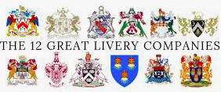

This lecture is an introduction to the Senior Livery Companies of the City of London, their medieval origins and their role in modern society. Some Companies maintain fine Livery Halls with historical and art treasures. They support charitable causes and play an important role in education. Only Liverymen and Liverywomen may elect the Lord Mayor and Sheriffs of London.
Fenella Billington has an MA in Art History from Manchester University. As a Liverywoman of the Worshipful Company of Skinners in London, she took the history of the Company and its art treasures as the subject for her master’s thesis. She is a tour guide and a freelance speaker for The Arts Society, The Art fund and the National Trust.

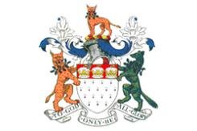
The Skinners’ Company

Monday 16 March
‘Dickens, Lawrence & Zhivago: David Lean’s Art of Cinema’
Neil Faulkener

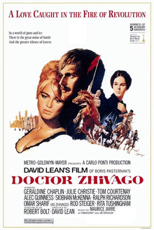

Cinematic images are modern art forms. In the ‘golden age’ of cinema – before the development of CGI technology – film-makers had to construct sets to represent landscapes, townscapes, and interiors. Sometimes they used paintings and photographs, sometimes they built scale models, sometimes they constructed full-size replicas. In each case, they created an art installation they then captured in celluloid images.
Drawing on new insights from the archaeology of cinema, this lecture will use the films of renowned British director David Lean to explore the art of cinema. How do the ‘artists’ – in this case formed of large collaborative teams (directors, screenwriters, production designers, costume designers, camera crews, fixers, etc.) – choose locations, construct sets, dress actors, and, more generally, ‘imagine’ the world they seek to represent? How much is authentic, and how much preconception and prejudice? What are the influences on the way the cinema depicts the world?

Dr. Neil Faulkner was educated at King’s College, Cambridge and Institute of Archaeology UCL. He works as lecturer, writer, archaeologist and occasional broadcaster. Current positions include Research Fellow at the University of Bristol, Editor of Military History Monthly, Director of Sedgeford Historical and Archaeological Research Project, and Director of the Great Arab Revolt Project. He has had many television appearances, including Channel 4 Time Team and BBC2 Timewatch.

